EXAM REGISTRATION

USE CASE DIAGRAM

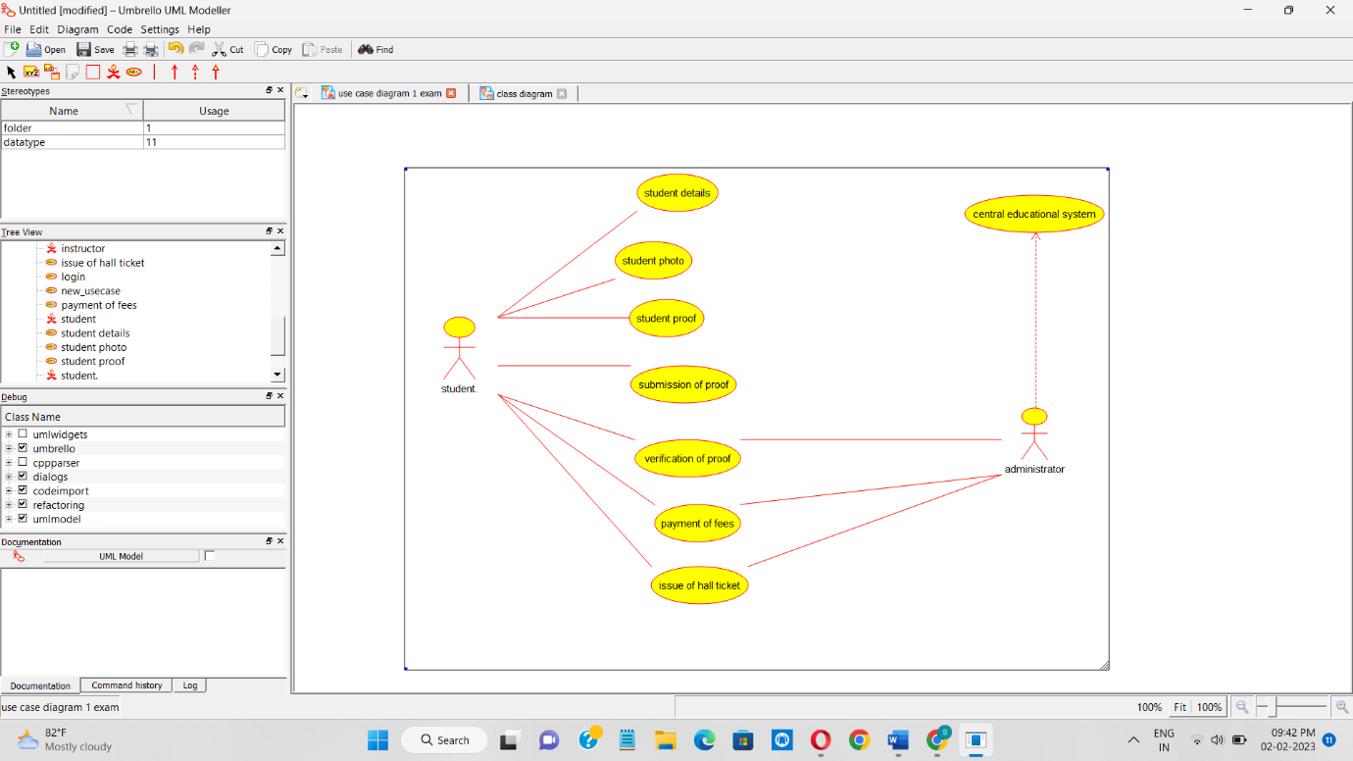

CLASS DIAGRAM

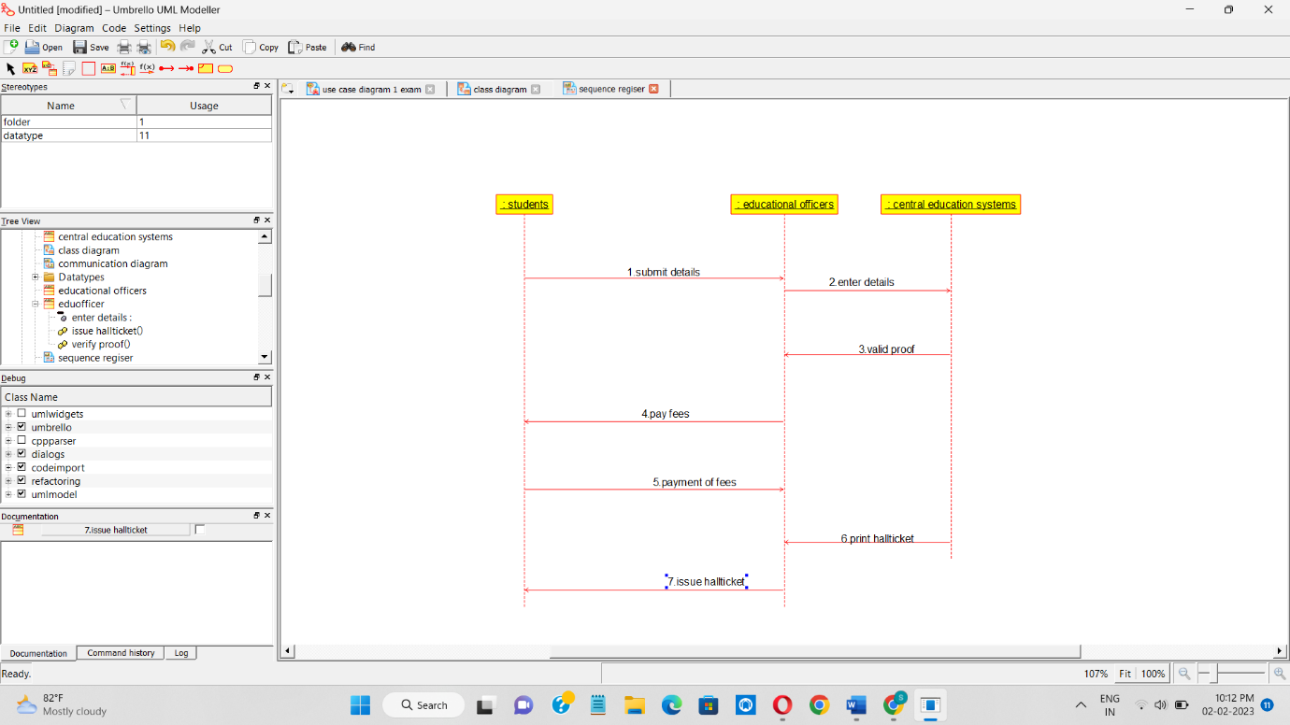

CLASS DIAGRAM

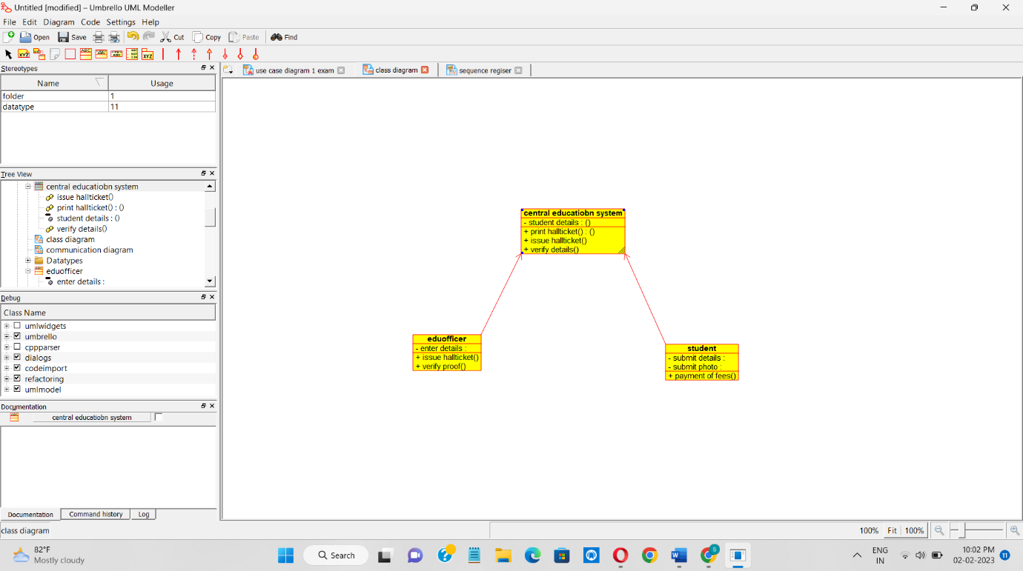

COLLABORATION DIAGRAM

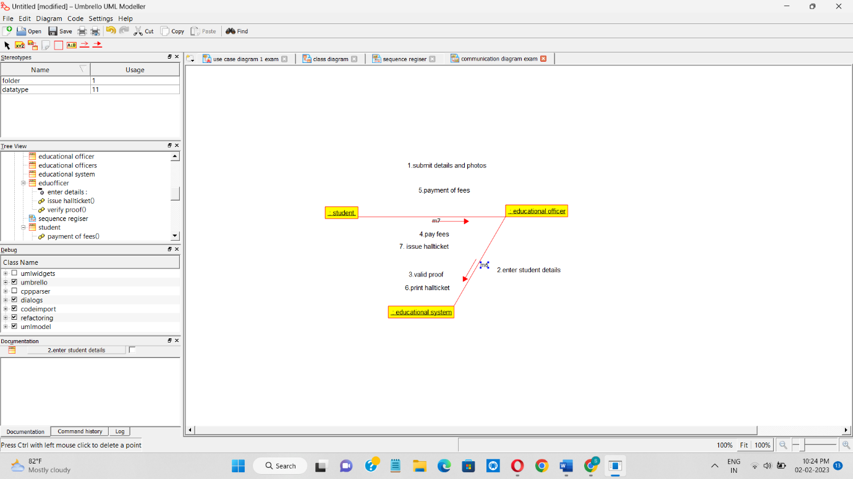

ACTIVITY DIAGRAM

